An R function max.incongr.f is developed for modelling independent observations (with no missing values) of a response variable Z by two independent variables X and Y, and assessing to what extent there is congruence. The models should include considerable interaction. Ideally, congruence (ref) is that the response is highest (if a high value of response is beneficial) along the congruence line X=Y, and also with a marked top where X=Y, along all lines of incongruence line. Incongruence lines are lines perpendicular to the congruence line. In the models, X and Y are grand mean centered, centered at the mean of X and Y together. The main incongruence line is through the center point where Xc and Yc (X and Y centered) are both 0, and is considered as particularly important.

There is a considerable literature (ref) on Response surface analysis (RSA), where specific polynomial regression models are used. Specifically, quadratic and cubic regression models. As shown in the RSA literature (ref), there are strong symmetry assumptions in quadratic models, that may not generally be assumed. The cubic models do not rely on such strong assumptions. But generally, polynomial regression is known to be vulnerable to substantial artefacts and may give artificially high values in the outer parts of the data range (ref Harrell). In RCA, it will be made possible to use a large number of model types. At present, quadratic and cubic models are available, as are models with restricted cubic splines with 4 knots (ref Harrell), both with unrestricted and restricted interaction structures. Other types of regression models may be included.

The function max.incongr.f computes characteristics that are of interest for assessing congruence. A plotting function plot.congr.maini plots the predicted response along the congruence line, together with its 95% confidence bands, and also the maximum predicted value along all incongruence lines. The predicted response along the main incongruence line is also included, in addition to predicted response along a selected incongruence line. For the congruence and main incongruence lines, the parts included in the convex hull of data for the predictors is highlighted, and the selected incongruence line is only shown within the convex hull.

So far the procedure has been used for a data set available in <http://public.kenan-flagler.unc.edu/faculty/edwardsj/downloads.htm> made available by Jeffrey R. Edwards accompanying his article (1994) The study of congruence in organizational behavior research: Critique and a proposed alternative), as described in supplementary material to the article Cubic Response Surface Analysis: Investigating Asymmetric and Level-Dependent Congruence Effects With Third-Order Polynomial Models by Humberg et al. Here, data on the predictor variables MRACT and MRPRE and the response variable MRSAT are used.

The following plot shows grand mean centered data for the predictors together with the convex hull

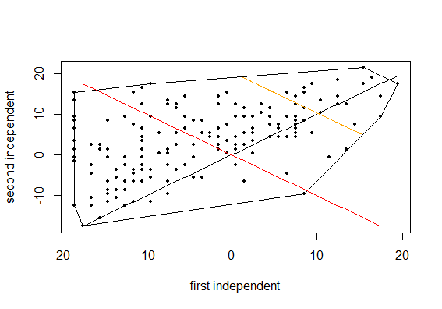

The black line is the line of congruence, the red line is the main line of incongruence and the orange line is a selected other line of incongruence. Note that the selected incongruence line is only depicted within the convex hull. The line of congruence is limited to the common range of the two predictors, from the maximum of their minima to the minimum of their maxima.

The following diagram shows the predicted response along the congruence line (black), for a model based on restricted cubic splines with a restricted interactions.

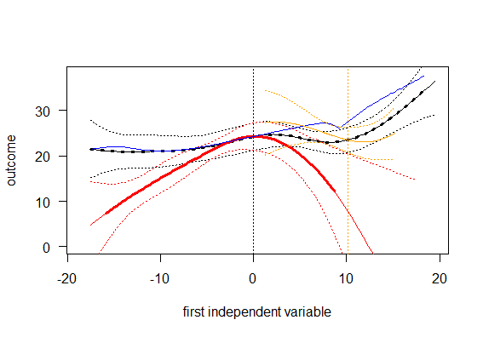

The black curve shows the predicted values along the congruence line, with points within the convex hull highlighted, and confidence bands dotted. The red curve shows the predicted values along the line of incongruence, also with points within the convex hull highlighted. The orange curve shows predicted values along the selected incongruence line, within the convex hull only. Finally, the blue curve shows the maximum values along each incongruence line, restricted to the convex hull. For the selected incongruence line the maximum, along the orange curve is consistent with the blue value at the position of this incongruence line, a little above 10, shown by a dotted vertical orange line.

We see that as long as the first independent variable is below the grand mean, the maximum (bølue9 is only slightly above the predicted value along the congruence line. This is good congruence. Above the grand mean, however, the maximum is increasingly more above the predicted value along the line of congruence, and even above its upper confidence band. Thus, the congruence is poorer in the portion of the congruence line to the right of the grand mean.

For a model with restricted cubic splines with all interactions, this diagram is 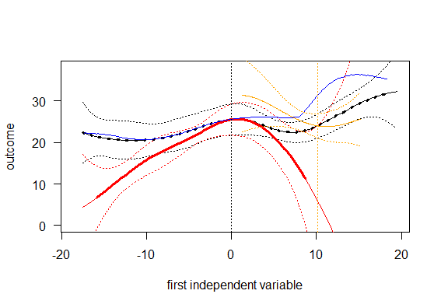

The congruence is a bit worse above the grand mean. The diagram is as follows for a quadratic model

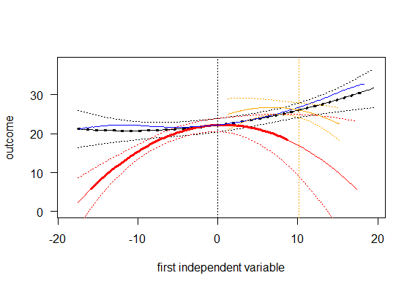

The congruence is good also to the right of the grand mean, but we see the strong symmetry assumptions underlying quadratic regression models. Finally, the diagram is as follows for a cubic model

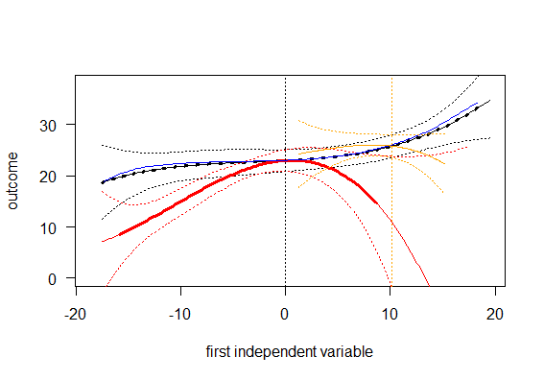

For a cubic regression model also, there is good congruence along the whole line of congruence. What model type to prefer is not a clearcut decision. Perhaps the range of data is sufficiently compact in this data set, that a cubic model may be used. One possibility is to compare the models by criteria including the Akaike and Bayesian information criteria (AIC and BIC),

|  |  |  |
| --- | --- | --- |
| Model | AIC | BIC |
| Restricted cubic splines, restricted interactions | 1144.61 | 1185.53 |
| Restricted cubic splines, all interactions | 1149.86 | 1203.36 |
| Quadratic | 1142.58 | 1164.62 |
| Cubic | 1147.45 | 1182.07 |

Then, the quadratic model would be preferred using both AIC and BIC. If another model without strong symmetry assumptions is preferred, the model with restricted cubic splines, restricted interactions is preferred by AIC and the cubic model by BIC.